Exercise 10

Write a web page that enables the user to play the game of 15. There is a 4-by-4 board (implemented as an HTML table) for a total of 16 slots. One of the slots is empty. The other slots are occupied by 15 tiles, randomly numbered from 1 through 15. Any tile next to the currently empty slot can be moved into the currently empty slot by clicking on the tile.

Your program should create the board with the tiles out of order. The user’s goal is to arrange the tiles in sequential order row by row.

Basic Functions (基本題80%):

1. Please use the API of DOM and the mouseover/mouseout event to show the description of the cell that **the mouse cursor hovers over**. The descriptions include: "This is a blank cell!", "This tile can move up!", "This tile can move down!", "This tile can move left!", "This tile can move right!", and "Illegal move!".

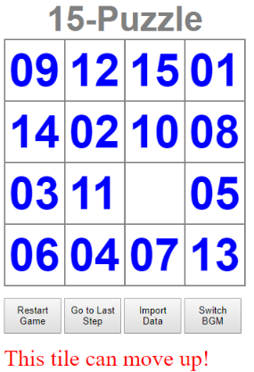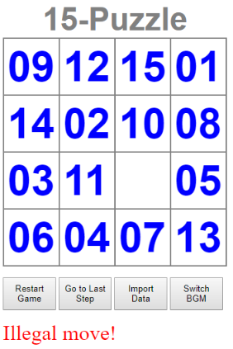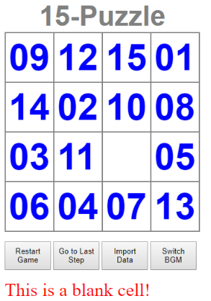

1. Please use the DOM and the onclick event (using pure JavaScript or jQuery) to allow the user to swap the positions of the open position and an adjacent tile.

Click [**05**] 🡪

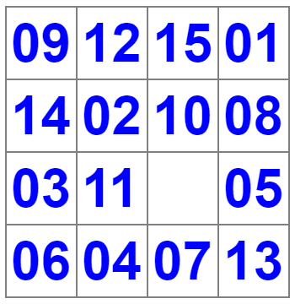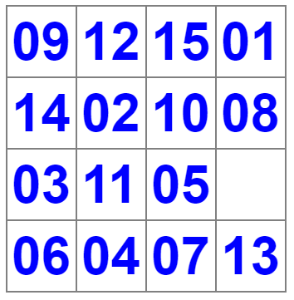

Hints:

* The onclick event should be specified for each table cell.
* You can write your script based on ex-10-partial.html.

Advanced (進階題40%):

1. Determine when **the game is over**, then **play the music of applause** and prompt the user to determine whether to play again. (Add a “checkWin()” function for each move).
2. Allow the user to **restart** the game. (Add a “restart()” function for the “Restart” button)
3. Allow the user to **go to the last step.** (Add a “gotoLastStep()” function for the “Goto Last Step” button) 🡪改變數字排列(不能每次空白格位置都相同)，讓使用者只要再走一步就可以完成遊戲。
4. **Play/pause** a background music “offlimits.mp3”. (Add a “playBGM()” function for the “Switch BGM” button) 🡪透過點擊此button可開啟/關閉背景音樂，開啟後應循環播放。

Bonus (加分題20%):

1. Import external JSON data to initialize the puzzle. (Add a “importData()” function for the “Import Data” button ) 🡪由於不是每個隨機產生的數字排列都可以完成遊戲，你可透過jQuery之getJSON方法從下面三個網址隨機挑選一個，以進行初始數字之設定，應取得之資料為puzzleData[0]之二維陣列。

* <https://api.myjson.com/bins/yni16>
* <https://api.myjson.com/bins/worqi>
* <https://api.myjson.com/bins/ude6y>

Hints:

1. Use the <audio> tag to play background music.

* https://www.w3schools.com/tags/tag_audio.asp
* <https://www.w3schools.com/tags/ref_av_dom.asp>

1. Use the jQuery getJSON() API to obtain the puzzle data.

* <https://www.w3schools.com/jquery/ajax_getjson.asp>